

**Marriage RenewaL of Vows**

This cerTificaTe cerTifies ThaT This Loving coupLe

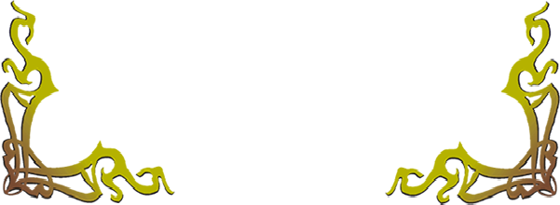

have come TogeTher afTer years of marriage

on This joyous day of To renew and

reaffirm Their wedding vows and

commiTmenT To one anoTher.